Supplementary Information

A thermodynamic description of the Co-Cr-Fe-Ni-V system for high-entropy alloy design

¹Won-Mi Choi, ¹Yong Hee Jo, ¹Dong Geun Kim, ²Seok Su Sohn, ¹Sunghak Lee,
¹Byeong-Joo Lee*
¹Department of Material Science and Engineering,
Pohang University of Science and Technology (POSTECH), Pohang 37673, Republic of Korea
²Department of Material Science and Engineering,
Korea University, 145 Anam-Ro, Seongbuk-Gu, Seoul 02841, South Korea

Quinary expansion of the ternary interaction parameter (L)

The term “*” has been introduced to the interaction parameter (L) for thermodynamic calculations extended to higher order systems. The L parameters with “*” are assumed to be independent from the atom occupancy in the corresponding sublattice. For example, in the Co-Cr-Fe system, the σ phase was modeled with the formula unit, (Co, Fe)₈ (Cr)₄ (Co, Cr, Fe)₁₈, and three interaction parameters, L^{σ}(Co,Fe:Cr:Co), L^{σ}(Co,Fe:Cr:Cr) and L^{σ}(Co,Fe:Cr:Fe), are introduced with the same value to reproduce the experimental information. Here, it is more consistent that two interaction parameters, L^{σ}(Co,Fe:Cr:Ni) and L^{σ}(Co,Fe:Cr:V), are also given the same value in the Co-Cr-Fe-Ni-V quinary system which has the formula unit, (Co, Fe, Ni)₈ (Cr, V)₄ (Co, Cr, Fe, Ni, V)₁₈ for the σ phase. Here, these five L parameters are denoted as L^{σ}(Co,Fe:Cr:*). All of the present L parameters in each ternary assessment were optimized with the same strategy.

During the review and revision process, the authors realized that one type of ternary interaction parameter, L^{σ}(Fe:Cr:Fe,V), was missed in expanding into the quinary system. For the Co-Cr-Fe-Ni-V quinary system, vanadium is the only element that enters into the second sublattice in addition to Cr. The fact that only L^{σ}(Fe:Cr:Fe,V) was used in the Cr-Fe-V system means that L^{σ}(Fe:V:Fe,V) was not necessary for the thermodynamic assessment of the Cr-Fe-V system and can be ignored in the Cr-Fe-V containing higher order systems. Now, the issue is whether the parameter L^{σ}(Fe:Cr:Fe,V) should be used alone or should be used in a form of L^{σ}(*:Cr:Fe,V) which looks more consistent. If the parameter L^{σ}(Fe:Cr:Fe,V) is thought as one of the parameter of the L^{σ}(*:Cr:Fe,V) type, two more parameters, L^{σ}(Ni:Cr:Fe,V) and L^{σ}(Co:Cr:Fe,V), can be assigned a non-zero value. The validity of those parameters can be examined in experimental investigations on the Cr-Fe-Ni-V and Co-Cr-Fe-Ni-V systems.
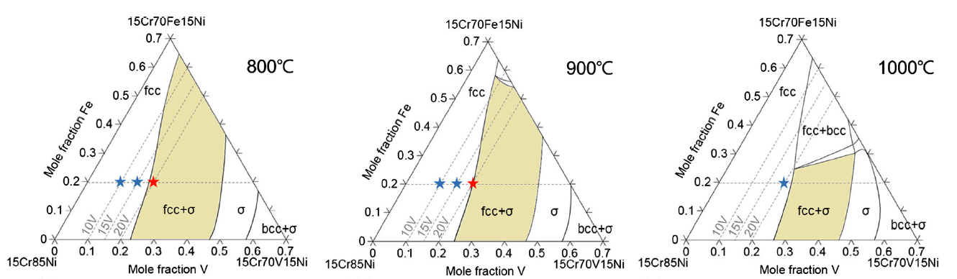
- when using L^{σ}(Fe:Cr:Fe,V) = -235158

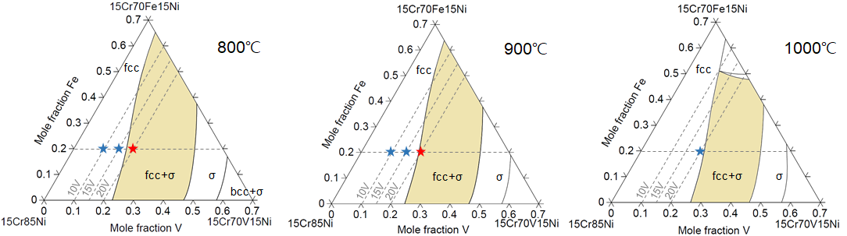
- when using L^{σ}(*:Cr:Fe,V) = -235158

Figure S1. 15 at% Cr Iso-concentration sections in the Cr-Fe-Ni-V system at 800, 900 and 1000 ºC

Fig. S1 shows calculated 15 at% Cr Iso-concentration sections in the Cr-Fe-Ni-V system at 800, 900 and 1000ºC (a) when only L^{σ}(Fe:Cr:Fe,V) = -235158 is used and (b) when L^{σ}(*:Cr:Fe,V;0) = -235158 is used. Here, the compositions marked with a blue star “★” indicate that the alloys show fcc single phase microstructure experimentally at each annealing temperature, and the alloys of the composition marked with red star “★” show the formation of sigma phase in the fcc matrix [1]. One can see that the use of both L^{σ}(Fe:Cr:Fe,V) = -235158 and L^{σ}(*:Cr:Fe,V;0) = -235158 describes the stability of the σ phase equally well or even better.

Concerning the validity of using the L^{σ}(*:Cr:Fe,V) parameter, as mentioned in the main text, there are some (unpublished) experimental data on the stability of the sigma phase in the Co-Cr-Fe-Mn-Ni-V system. When using only the L^{σ}(Fe:Cr:Fe,V) parameter, the present description was certainly underestimating the stability of the sigma phase in the hexanary system. According to the formula unit of the sigma phase for the Co-Cr-Fe-Mn-Ni-V system, (Co, Fe, Mn, Ni)₈ (Cr, V)₄ (Co, Cr, Fe, Mn, Ni, V)₁₈, three more parameters, L^{σ}(Co:Cr:Fe,V), L^{σ}(Mn:Cr:Fe,V) and L^{σ}(Ni:Cr:Fe,V), could be given a non-zero value by using the L^{σ}(*:Cr:Fe,V). In the case of the hexanary system, the use of L^{σ}(*:Cr:Fe,V) = -235158 instead of L^{σ}(Fe:Cr:Fe,V) = -235158 increases the stability of the sigma phase as can be expected easily from its negative value, and thus improve the thermodynamic prediction on the stability of the sigma phase. The detailed experimental work and calculation results for the hexanary system will be reported seperately. In summary, the interation parameter L^{σ}(Fe:Cr:Fe,V), originally from the Cr-Fe-V description [2], was extented to the parameters L^{σ}(*:Cr:Fe,V) in the present work, better describing the stability of the σ phase in higher-order systems.

Reference

1. W.-M Choi, Y. H. Jo, D. G. Kim, S. S. Sohn, S. Lee, B.-J. Lee, A thermodynamic modelling of the stability of sigma phase in the Cr-Fe-Ni-V high-entropy alloy system, J. Phase Equilib. Diffus. 39 (2018) 694-701.
2. B.-J. Lee, A Thermodynamic Evaluation of the Fe-Cr-V System, Z. Metallkd. 83 (1992) 292-299.

